Wheat seeds analysis based on their geometrical properties

Mohit Mehndiratta, 20622275
Master of Data Science
Western Sydney University

Abstract— Cultivation of wheat grass for its seeds and cereal grains are done worldwide. It is the most important and widely used food grain across the globe. There are several types of wheat kernels but here we will discuss only three types of wheat mainly “Kama”, “Rosa” and “Canadian”. Accurate classification of wheat types is required for the companies working under this domain to store the seeds. Nowadays, identification of wheat seeds is done with the labor force and under continuous supervision. However, this is not the productive way to perform this kind of classification manually because there are always a concern of human error and operational workload for employees. Due to this and organization might have to bear some losses as well. For this, Machine Learning can be very helpful to automate this process of classifying wheat seeds based on their kernels. Machine learning or data analysis is about extracting meaningful properties from a data. In this report, we used classification technique to classify and accurately predict whether a particular wheat has a type “Kama” or not.
Keywords— Wheat analysis, classification, kernels, regression, data analysis, data explore, data preprocessing,

Introduction
Wheat grass is cultivated worldwide for its seeds and cereal grains. It is the most widely used food grain in terms of cereal grains superseding maize and rice as a source of protein. Wheat is eaten in 89 countries across the world. Wheat has various types and ways to be cultivated and originated. Out of various types of wheat in this report we will talk about “Kama”, “Rosa” and “Canadian” wheat types.
In many factories and warehouses where wheat is stored after the production, accurate classification of wheat kernels is required so that they don’t mix with one another. This important for an industrial point of view because mistakes like this can cause serious business losses. In today’s time wheat are mainly classified with labor forces manually, resulting in increased time and manual errors. Therefore, it is important to have an autonomous system that can provide wheat classification based on their geometrical properties. This will result in reduced manual load, time, and mistakes.
Machine learning can be very helpful for automating the classification of wheat seeds as per their types. With the data we can perform various methods for classification and train the model to have maximum accuracy.
In this report, we have used wheat seeds data set that is available at UCI machine learning repository. The data is about wheat kernel types “Kama”, “Rosa” and “Canadian” having their respective geometrical properties. These properties are Area, Perimeter, Compactness, Length of Kernel, Width of Kernel, Asymmetry Coefficient and Length of Kernel Groove.
The main objective of this work is to use a classification technique to correctly classify whether a particular observation of wheat is of a type “Kama” or not. Here, we will use 2 methods of classification techniques under supervised learning and 1 method of unsupervised learning. Post which we will compare the results of each method and find the best model that can accurately classify whether a particular wheat is “Kama” or not. To do this, first data exploration and preprocessing is required to modify and select the appropriate data for this specific task.

Data Description Explore And Pre Processing

Exploring the data is one of the first steps in data preparation. It is a way to get to know the data before working on it. Data exploration allows deep understanding of data and its properties.

1. Data Description Explore

Describe data
We have gathered data from UCI machine learning repository and is called “seeds data set”. The data set comprises measurements of structural properties of seeds belonging to three different types of wheat. These types are “Kama”, “Rosa” and “Canadian”. The data set is multivariate. There are a total of 210 observations with 8 variables.

Explore data
We are exploring the data using R and R studio as a tool. Upon looking at firs few observations of the seeds data set we can find that there are a total of 210 observations for 8 variables. The variables are Area A, Perimeter P, Compactness C = 4*π*A / P², Length of kernel, Width of kernel, Asymmetry Coefficient, Length of kernel groove and Type.
TABLE 1: SEEDS DATA SET (First 5 Rows)
Area | Perimeter | Compactness | Length | Width | Asymmetry | Length Groove | Type
15.2 | 14.8 | 0.871 | 5.76 | 3.31 | 2.22 | 5.22 | 1
14.8 | 14.5 | 0.881 | 5.55 | 3.33 | 1.01 | 4.95 | 1
14.2 | 14.0 | 0.905 | 5.29 | 3.33 | 2.69 | 4.82 | 1
13.8 | 13.9 | 0.895 | 5.32 | 3.37 | 2.25 | 4.80 | 1
16.1 | 14.9 | 0.903 | 5.65 | 3.56 | 1.35 | 5.17 | 1
The observations are divided into 3 sets of 70 as per its types. All the variables are numeric in nature except “Type”. “Type” is an integer type variable of value 1,2 and 3 for “Kama”, “Rosa” and “Canadian” respectively.
The variable descriptions are as follows:
- Area represents Area of a kernel/seed.
- Perimeter is the perimeter of a kernel
- Compactness is calculated with the help of area and perimeter, formula is C = 4*π*A / P².
- Length of Kernel is the total height of the seed.
- width of kernel represents how wider the seed is.
- Length of kernel groove depicts the height of the groove inside the kernel.
- Asymmetry coefficient represents how symmetric a kernel is if we divide the seeds into 2 parts and compare it with left and right area.
From the correlation matrix, it is evident that Area, Perimeter, Length of Kernel, Width of Kernel and Length of Kernel Groove are strongly correlated with one another. While Compactness is somewhat correlated with Width of Kernel. On the other hand, Asymmetry Coefficient shows weak negative correlation with each variable.

Box Plots in figure 1, shows us that according to geometric parameters of seeds, Rosa is the largest seed and Canadian type seeds are the lowest. Compactness of Kama and Rosa are similar while Asymmetry coefficient is the only variable where Canadian seeds has highest value meaning Canadian kernels are more symmetric than others.
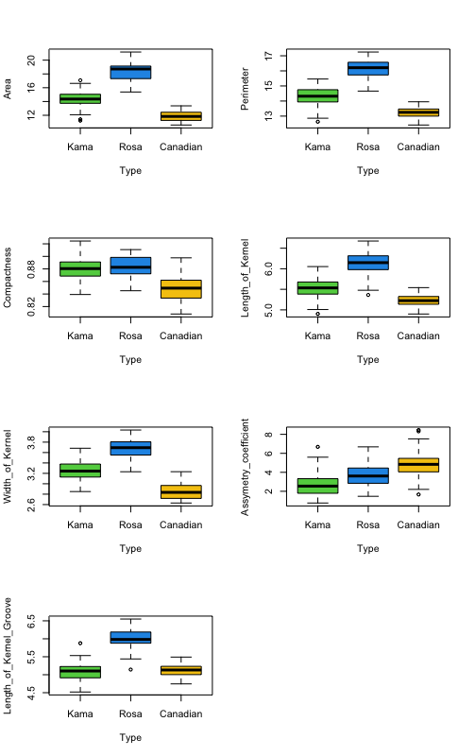 FIG 1: WHEAT TYPES BASED ON THEIR GEOMETRICAL PROPERTIES

Quality of the Data
The data doesn’t have any null or NA values in there. The data set seems clean as of now.

2. Data Pre-Processing
Data Preprocessing is a data mining technique that involves transforming some raw data into meaningful format as per our goal. Data often consists of null values, some outliers, not as per our goal, not properly classified and that’s when preprocessing come in before we use the data for model building process.
As per seeds data set, there are few preprocessing of data that is required to finally use the data for our desired goal.

A. Construct data
The seeds data set has a “Type” variable which consists of 3 values mainly 1,2 and 3 indicating “Kama”, “Rosa” and “Canadian” respectively. As per our aim, we need to classify a variable to see if it’s a “Kama” type or not. Therefore, with the use of “Type” variable, where we know 1 represents “Kama”, we will be constructing a new variable named “is_Kama” where 1 represents “Kama” and 0 represents “Not Kama”.
Post constructing this new variable, a new data is formed by sub-setting “Area”, “Perimeter”, “Compactness”, “Length of Kernel”, “Width of Kernel”, “Asymmetry Coefficient” and “Length of Kernel Groove” along with “is Kama” variable.
B. Conversion to categorical variable
From the data exploration, we observed that R recorded “is Kama” variable as an integer type variable while we know that it is a factor variable of 2 levels mainly 0 and 1. “is Kama” being our response variable must be a factor/categorical variable to create the models based on classifications. Therefore, we use R Code to transfer the class of “is Kama” variable from integer to numeric by using “as.factor” function.

C. Dividing data into training and testing data set
Another part of data preprocessing is dividing the data into training and testing data where model is trained on the training data set and then validated on testing data set. This is done so that we can predict model using unseen data which can give us the true accuracy of a model.
As far as our research is concerned, we will randomly divide our data set into 70% and 30% each for training and testing data respectively. Here, we chose 70% training data because we want our model to train better and the more the data the more accurate can model be.

Aims And Objectives
A warehouse wants to store the seeds of wheat type “Kama” in a particular section, therefore based on seeds geometrical properties they want to classify and identify the correct “Kama” wheat type so that they can store and pack them without any human error.

The Aim of this project is as follows:

- To correctly classify the “Kama” wheat type from the seeds data set.
- To understand which of the geometric properties are more important to classify the wheat type “Kama”.
- To experiment with different classification methods to which methods yields the highest accuracy for the above problem.

